网站个人信息

姓 名 | 廖玮 | 性 别 | 男 |  | 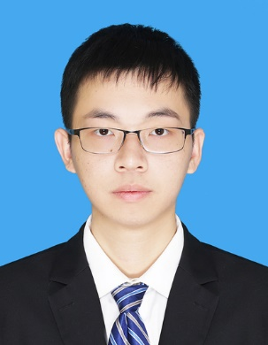
国 籍 | 中国 | 学 位 | 博士
所学专业 | 飞行器设计 | 毕业院校 | 南京航空航天大学
职 称 | 讲师 | 职称类别 | 中级 | 导师类别
电子邮件 | liaowei1991@ncu.edu.cn | 所在单位 | 先进制造学院
个人信息
教育经历 | 2008.9-2012.6，南昌航空大学，飞行器设计与工程  2013.9-2016.4，南京航空航天大学，飞行器设计  2017.4-2021.7，南京航空航天大学，飞行器设计
工作履历 | 2016.4-2017.3，洪都集团飞机设计所
科研项目
科研成果 | 1. An Improved Level Set Method for Reachability Problems in Differential Games，IEEE Transactions on Systems, Man, and Cybernetics: Systems  2. A dimensionality reduction method for computing reachable tubes based on piecewise pseudo-time dependent Hamilton–Jacobi equation，Applied Mathematics and Computation  3. Probabilistic reach-Avoid problems in nondeterministic systems with time-Varying targets and obstacles，Applied Mathematics and Computation

