网站个人信息

姓 名 | 李文超 | 性 别 | 男 | 照片 | 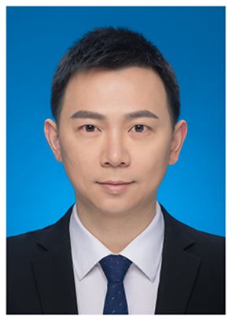  一寸蓝底证件照
国 籍 | 中国 | 学 位 | 博士
所学专业 | 材料加工 | 毕业院校 | 华中科技大学
职 称 | 中级 | 职称类别 | 讲师 | 导师类别
电子邮件 | Chadli@ncu.edu.cn | 所在单位 | 先进制造学院
个人信息 | 李文超，博士，主要从事3D打印设备、工艺及应用相关研究，与企业合作开展半导体磨抛设备、工艺及耗材的关键技术研究，发表相关SCI论文20余篇。
教育经历 | 2014.9-2018.6 华中科技大学 材料加工 博士研究生
工作履历 | 2018.7-至今 南昌大学先进制造学院 讲师  2009.6-2014.1 武汉新芯集成电路制造有限公司 制程整合工程师
科研项目 | 可定制多喷头生物3D打印技术与装备  导管类（抗菌、微量泵延长管）开发
科研成果 | - Li, Yihan; Yu, Zehao; Ai, Fanrong; Wu, Chunxuan; Zhou, Kui; Cao, Chuanliang; Li, Wenchao; Characterization and evaluation of polycaprolactone/hydroxyapatite composite scaffolds with extra surface morphology by cryogenic printing for bone tissue engineering, Materials and Design, 2021, 205: 0-109712 (期刊论文)  (2) Chunxuan, Wu; Zehao, Yu; Yihan, Li; Kui, Zhou; Chuanliang, Cao; Peng, Zhang; Wenchao, Li; Cryogenically printed flexible chitosan/bioglass scaffolds with stable and hierarchical porous structures for wound healing, Biomedical Materials, 2020, 16: 0-015004 (期刊论文)  (3) Li wenchao; Shi Lei; Zhou Kui; Zhang Xianglin; Ismat Ullaha; Ou Hao; Zhang Wancheng; Wu Tianjun ; Facile fabrication of porous polymer fibers via cryogenic electrospinning system, Journal of Materials Processing Technology, 2018, 266(April 2019): 551-557 (期刊论文)  (4) Zhang, Wancheng; Ullah, Ismat; Shi, Lei; Zhang, Yu; Ou, Hao; Zhou, Jinge; Ullah, Muhammad Wajid; Zhang, Xianglin; Li, Wenchao ; Fabrication and characterization of porous polycaprolactone scaffold via extrusion-based cryogenic 3D printing for tissue engineering, Materials and Design,  2019, 180: 0-UNSP 107946 (期刊论文)  (5) Li, Wenchao; Shi, Lei; Zhang, Xianglin; Liu, Kang; Ullah, Ismat; Cheng, Penghua ; Electrospinning of polycaprolactone nanofibers using H2O as benign additive in polycaprolactone/glacial acetic acid solution, Journal of Applied Polymer Science, 2018, 135(3): 0-45578 (期刊论文)

